**Assignment #4**

**Analytics for decision support**

1. (i) Total Number of shares sold for each stock = 8

We will represent our decision variables as set of variables X[i] where X is number of shares to be sold for ith stock in an array form. Below table represents all individual decision variables:

|  |  |  |  |
| --- | --- | --- | --- |
| **Decision variable  X [i]** | **Value of i** | **Name of stock** | **Definition** |
| **X [1]** | 1 | Yahoo | Numbers of Yahoo shares to be sold this year |
| **X [2]** | 2 | General Electric | Number of General Electric shares to be sold this year |
| **X [3]** | 3 | Microsoft | Number of Microsoft shares to be sold this year |
| **X [4]** | 4 | Bank of America | Number of Bank of America shares to be sold this year |
| **X [5]** | 5 | JP Morgan Chase | Number of JP Morgan Chase shares to be sold this year |
| **X [6]** | 6 | Cisco Systems, Inc. | Number of Cisco Systems, Inc. shares to be sold this year |
| **X [7]** | 7 | Intel | Number of Intel shares to be sold this year |
| **X [8]** | 8 | Pfizer | Number of Pfizer shares to be sold this year |

Also, we will define purchased price as P [i], current price as C [i] and price estimated next year as E [i], i being same index as for X.

(ii) We own 150 shares for each stock so can’t sell more than 150. Thus, 150 is the upper bound for each stock.

Considering X being numbers of shares to be sold for this year with index i which defines the stock and varies from 1 to 8 as below.  
Upper bound constraint: X[i] <= 150

Also, number of stocks to be sold can’t be negative.   
Lower bound constraint: X[i] >= 0

Finally, following are the constraints on decision variable:  
  
Highest numbers of shares which can be sold for each stock: X [i] <= 150;  
Lowest numbers of shares which can be sold for each stock (Non-negativity): X [i] >= 0;

(iii) We expect the stock for Microsoft to be worth $34.55 next year, since we will have (150 – x[3]) shares next year (after selling x[3] shares), the estimated value of your stock is $34.55(150 – x[3]).

(iv) Objective function could be given by,  
Maximize next_year_price: Number of shares of each stock * price estimated next year

=

(v) First, we will define purchased price as P [i], current price as C [i] and price estimated next year as E [i], i being same index as for X.

Now,   
Unit price for shares if sold today: C [i]  
Unit capital gain taxes if sold today: 30% of (C [i] – P [i]) = 0.3*(C [i] – P [i])  
Unit transaction cost if sold today: 1% of C [i] = 0.01*C [i]

Total unit price: C [i] - 0.3*(C [i] – P [i]) - 0.01*C [i] = 0.69*C [i] + 0.3*P[i]

Number of shares for each stock (to be sold today) = X [i]

Constraint could be given by:  
Money_Required_Today: = 10000 (as we need total of $10000 today)

B) (i) Optimal solution is to sell 67.7233 shares of Yahoo, 150 shares of Microsoft and 150 shares of Intel today to earn $10000 after taxes and transaction costs.

Below screen shot (from AMPL) gives optimal solution with decision variable values and objective function value.

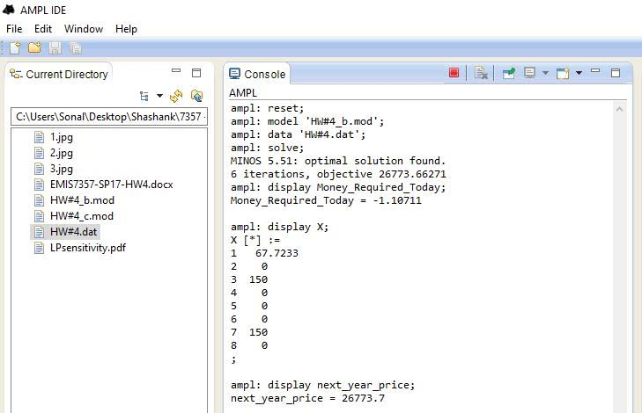

(ii) The investments get diversified as we have 8 different stocks and as an investor it turns out be a good deal. Even if one or two stocks do not do good this year there is still a chance with the rest of the stocks. For our optimal solution, we choose to sell all our shares of some stocks, but keep at least half of the shares of each of other stocks. This proves out to be a decent solution.

C) (i) Optimal solution is to sell 75 shares of Yahoo, 75 shares of General Electric, 75 shares of Microsoft, 4.59928 shares of Cisco, 75 shares of Intel and 75 shares of Pfizer today to earn $10000 after taxes and transaction costs.

Below screen shot (from AMPL) gives optimal solution with decision variable values and objective function value.

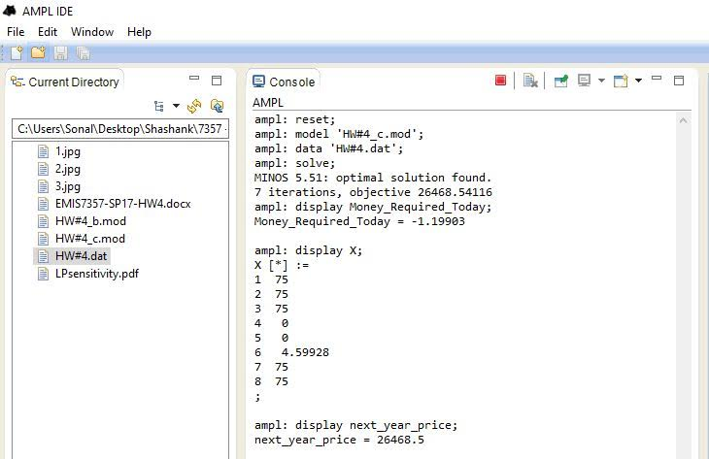

(ii) We are still diversifying here and though the investments are worth a bit less, this will help the long-term investors. We are expecting the Yahoo stock to decrease next year, so while we plan to sell no more than 75 shares of the other stocks we will sell 100 shares of the Yahoo stock.

Sensitivity Analysis:

1.For GE Appliance, the allowable increase has been added to its next year price(the allowable decrease is negligible), this will let us know how many shares must be sold in the current year.

* -26.31+ 0.4222
* $25.88, is the estimated value for the next year and hence 77.173 shares has to be sold in the current year.

2. For Microsoft, the allowable decrease must be subtracted form the next year share price, this will let us know how many shares must be sold in the current year.

* -34.55-0.3704
* $34.92, is the upper bound value for selling all the shares. If the share value is between $0- $34.92, the investor must be sell all the shares. If its greater than $34.92, the investor wouldn’t sell any.

3. As the amount to be generated increases, the number of stocks to be sold increases. However, the allowable increase is 2192 and the allowable decrease is 1804. Within this ranges we don’t see any decrease or increase of the stocks to be sold, that is it remains constant.